

**A**

**PROJECT REPORT**

**“hostel MANAGEMENT SYSTEM”**

**Submitted to**

**Savitribai Phule Pune University**

**In Partial Fulfilment of the requirements of the Award of the Degree of**

**BATCHLOR OF COMPUTER APPLICATION (SCIENCE)**

**By**

**Miss. SHIVANI NANDU BHALERAO**

**STUDENT OF THIRD YEAR B.C.A.(Science)**

**Under The Esteemed Guidance of**

**PROF.P.N.PATIL SIR**

**(HOD, Assistant Professor)**

**In**

**DEPARTMENT OF B.C.A.(Science)**

**K.J. Somaiya Collage of Arts, Commerce and Science, Kopargaon-423601**

**FOR ACADAMIC YEAR 2022-23**

**Kopargaon Taluka Education Society’s**

**K.J. SOMAIYA COLLAGE OF ARTS, COMMERCE AND SCIENCE**

**Mohanrajnagar,Kopargaon-423601,Dis-Ahemadnagar**



**Certificate**

This Is Certify That **Miss. Shivani Nandu Bhalerao** Student Of **B.C.A.Sci** Has A Complete Project Report On Presentation Report Of

**“HOSTEL MANAGEMENT SYSTEM”** Submitted In Partial Fulfilment Of It He Degree Of Baster Of Commerce As Per The Syllabus Of **SAVITRIBAI PHULE UNIVERCITY** For The Academics Year 2022-23

I Further Clarified That, The Work Has Been Carried Out Under My Guidance.

**Project Guide Head Of Department**

**Internal Examiner External Examiner**

**ACKNOWLADGEMENT**

At every student I express my gratitude to almightly lord for showering this grace and Blessing upon to me to complete this project.

Although the our name appears on the cover of this book, many people had contributed in some from on the other form to this project Development.

We could not done this project without the assistance or support of each of the following we thank you all.

I wish to place on my record my deep some of gratitude to my project guide, Prof.P.N.Patil, for his content motivation and valuable help through the project work.

Express my gratitude to Dr. B. S. Yadav, Principal and Prof. P.N.PATIL , Head of Department of K. J. Somaiya College, Kopargaon and Prof. P. N. Patil, Project Guide for his Valuable suggestions and advices throughout the BCA(Science) course. I also extend my thanks to other Faculties for their cooperation during my Course.

Finally, I would like to thanks my friends for their co-operation complete this project.

**Miss. Shivani Nandu Bhalerao**

**TY BCA(Science)**

**INDEX**

|  |  |  |
| --- | --- | --- |
| **Sr.No.** | **Title** | **Page No.** |
| 1. | Introduction To Project | 1 |
|  | * Background |  |
|  | * Objectives |  |
| 2. | Problem Defination | 3 |
| 3. | Introduction To Proposed System | 4 |
| 4 | Existing System | 5 |
|  | * Advantages |  |
|  | * Disadvantages |  |
| 5. | System Requirement | 6 |
|  | * Hardware Requirement |  |
|  | * Software Requirement |  |
| 6. | Scope Of System | 7 |
| 7. | Feasibility Study | 8 |
|  | * Technical Feasibility |  |
|  | * Economical Feasibility |  |
|  | * Operational Feasibility |  |
| 8. | ER Diagram | 10 |
| 9. | Data Dictionary | 11 |
| 10. | UML Diagrams | 13 |
|  | * Use Case Diagram |  |
|  | * Data Flow Diagram (DFD) |  |
|  | * Activity Diagram |  |
|  | * Component Diagram |  |
|  | * Deployment Diagram |  |
| 11. | System Testing | 19 |
|  | * Software Testing |  |
|  | * Types of Software Testing |  |
|  | 1. White Box Testing |  |
|  | 1. Black Box Testing |  |
|  | * Test Case |  |
| 12 | Input Screens | 26 |
| 13. | Output Screens | 31 |
| 14. | Limitations | 34 |
| 15. | Conclusion | 35 |
| 16. | References | 36 |

**Introduction To Project**

* 1. **Background**

 This Hostel Management System is developed in favor of the hostel management team which helps them to save the records of the students about their rooms and other things. It helps them from the manual work from which it is very difficult to find the record of the students and the information about those ones who had left the hostel years before.

This solution is developed on the plight of the hostel management team, through this they cannot require so efficient person to handle and manage the affairs of the students in the hostel, all you need to do is to login as administrator and you can see the information of all the students who have obtained and registered their hostel form, click verify to ascertain their eligibility and allocate them to the available hostel.

Identification of the problems of the existing hostel management leads to the development of computerized solution that will be compatible to the existing hostel management with the solution which is more users friendly and more GUI oriented. We can improve the efficiency of the hostel management, thus overcome the drawbacks of the existing management.

* 1. **Objectives**

The main objectives of this project work are that:

* Student will no longer apply for their hostels manually.
* The warden can see and access the student’s data.
* This also will reduce the manual work of the persons in admin penal.
* It helps the admin to know the number of students that can leave in a room and a block.
* To ensure that the number of student staying in a room does not exceed specified limit.
* Help the admin to disseminate information to students without calling for a meeting or moving room to room.
* To ensure that student remit the hostel property given to them before vacating the hostel.

**Problem Defination**

There are a lot of drawbacks in keeping and maintaining a hostel. Especially with a manual system. Since most hostels are being run by only one hostel manager, the number of students in a room are sometimes not known by the officer. He has to go room by room to ensure that a room is occupied or not. Sometimes people may be owing in the hostel and they are saved on papers or huge notebooks, and sometimes receipts. If the books should go missing or stolen, one would never be able to know if a student is owing or not. Room allocation also becomes a problem as the officer might not know which rooms are available or not. And some hostels have a lot of rooms or have mare storeys and it would be very tedious to go through all storeys in search of a free room for an applicant. Also the officer might not know the number of students in a room or know if a room is full or not.

**Introduction To Proposed System**

This software product the “Hostel Management System” to improve their service for all the students of the hostel. This also reduce the manual work of the person in admin panel and the bundle of registers that were search when to find the information of previous student, because through this system you can store the data of those students who had leaved the hostel. Through this you can check the personal profile of all the current students within few minutes the data base of the system will help you to check the fees of every students and the students hostel dues the student of the hostel will be recognized from the ID number allocated at the room rental time.in the last this system will improve the last this system will improve the management work in the hostel.

This system you can store the data of those students who had leaved the hostel three years ago. Through this you can check the personal profile all the current students within few minutes the data base of the system will help you to check a particular one.

**Existing System**

* **Advantages**
* Effective for any college and school.
* Time saving.
* Easy to use.
* Reduce paper work.
* Easy to handle
* Easy data updating
* **Disadvantages**
* Low Security
* More Human error
* Inaccuracy of data

**System Requirements**

* **Hardware Requirement:**
* **Processor**: Intel R core Tm i5/i3
* **Hard Disk**: 160 GB & Above
* **Ram**: 8 GB.
* **Monitor**: VGA/SVAG
* **Printer**: Inkjet
* **Mouse**: Optical Mouse
* **Software Requirement:**
* **Operating System**: Windows8 and Above Version
* **Front- End**: Java NetBeans
* **Back-End**: MySQL Database

**Scope of System**

This project aims at automating the hostel management for smooth working of the hostel by automating almost all the activities.

The software “Hostel Management System will be an application that will be used for maintaining the records in an organized manner and to replace old paper work system.

Updating and modifications will be easily achievable and all the calculations and accounting work would be accurate.

**Feasibility Study**

* The feasibility study is a major factor which contributes to the analysis & development of the system. The decision of the system analysis whether to design a particular system or not depends on its feasibility study.
* It enables us to determine the potential of existing system & improving it. It helps to know what should be embedded in the new system. It also helps to develop a cost-effective system. We can made better utilization of available resources. The project concept is feasible because of following:
* **Technical Feasibility:**
* Technical feasibility is the study of hardware and software requirement on which the application is to be used upon. It is important to consider the budget of the system or the overall cost.
* The proposed system is technically feasible as it has been developed with the help of available technology. The proposed System uses front end java NetBeans & back end tool is MySQL for storing & maintaining database. No expert man power is required for this purpose
* **Economical Feasibility:**
* The economical feasibility is considered in terms of money price value. The organization measure the cost effectiveness of the project. The economical feasibility of the proposed system is as under.
* The organization is ready to invest on proposed system for latest technology & best result.
* The unit has not be spend much amount for the computer hardware & software.
* The organization is in position & also incapable to pay for the system.
* **Operational Feasibility:**

The proposed system is very user friendly & the user is much easily able to interact with the system. Therefore the users will readily accept the system & data entry & making queries can be easily.

**ER Diagram**

Exit

Admin

Login

Manage

Room

Employee

Student

Pay

Pay

Payment

Fee

ER Diagram Hostel Management System

**Data Dictionary**

* Student Registration Table:

|  |  |  |  |
| --- | --- | --- | --- |
| Sr.No. | Attribute | Data Type | Constraint |
| 1 | Student ID | Integer | Primary key |
| 2 | Name | Varchar | Not Null |
| 3 | Father Name | Varchar | Not Null |
| 4 | Mother Name | Varchar | Not Null |
| 5 | Email | Varchar | Not Null |
| 6 | Mobile Number | Varchar | Not Null |
| 7 | College Name | Varchar | Not Null |
| 8 | Address | Varchar | Not Null |
| 9 | Aadhar Number | Varchar | Not Null |
| 10 | Class | Varchar | Not Null |
| 11 | Room No | Varchar | Not Null |
| 12 | Status | Varchar | Not Null |

* Room Information**:**

|  |  |  |  |
| --- | --- | --- | --- |
| Sr.No | Attribute | Data Type | Constraint |
| 1 | Room No | Varchar | Primary key |
| 2 | Activate | Varchar | Not Null |
| 3 | Room Status | Varchar | Not Null |

* Fees Details:

|  |  |  |  |
| --- | --- | --- | --- |
| Sr.No. | Attribute | Data Type | Constraint |
| 1 | Student ID | Integer | Not Null |
| 2 | Name | Varchar | Not Null |
| 3 | Class | Varchar | Not Null |
| 4 | Mobile Number | Varchar | Not Null |
| 5 | Room No | Varchar | Not Null |
| 6 | Month | Varchar | Not Null |
| 7 | Amount | Varchar | Not Null |

* Employee Registration Table:

|  |  |  |  |
| --- | --- | --- | --- |
| Sr.No. | Attribute | Data Type | Constraint |
| 1 | Employee Id | Integer | Primary key |
| 2 | Name | Varchar | Not Null |
| 3 | Father Name | Varchar | Not Null |
| 4 | Mother Name | Varchar | Not Null |
| 5 | Email | Varchar | Not Null |
| 6 | Mobile Number | Varchar | Not Null |
| 7 | Address | Varchar | Not Null |
| 8 | Aadhar Number | Varchar | Not Null |
| 10 | Designation | Varchar | Not Null |
| 11 | Status | Varchar | Not Null |

* Payment Details:

|  |  |  |  |
| --- | --- | --- | --- |
| Sr.No. | Attribute | Data Type | Constraint |
| 1 | Employee Id | Integer | Not Null |
| 2 | Name | Varchar | Not Null |
| 3 | Mobile Number | Varchar | Not Null |
| 4 | Email | Varchar | Not Null |
| 5 | Designation | Varchar | Not Null |
| 6 | Month | Varchar | Not Null |
| 7 | Amount | Varchar | Not Null |

**UML Diagrams**

* Use Case Diagram:

Hostel Management System

**Admin**

**System**

Use Case Diagram between Admin and System

* Data Flow Diagram DFD:

1. DFD Zero Level:

Login Management

Student Management

Employee Management

Employee Payment Management

Student Fee Management

Room Management

Zero Level DFD – Hostel Management System

1. DFD First Level:

Check User Login Details

Login Management

Generate Room Report

Room Management

Generate Student Report

Student Management

Generate Fee Report

Student Fee Management

Generate Employee Report

Employee Management

Generate Payment Report

Employee Payment Management

First Level DFD – Hostel Management System

* Activity Diagram:

Login

Check Login ID & Password

Student

Room

Employee

Add

Update & Delete

View

Log Out

* Component Diagram:

Fees.java

Student.java

HomePage

Payment.java

Employee.java

Room.java

Database

ggg

MySQL

* Deployment Diagram:

Hostel Management System

Windows OS

MySQL Database

**System Testing**

* Software Testing:

Is all the link of website that works done properly? All input type that work properly or not & button that work or not or data feeding is properly operation and Tool-bars work properly? Is it possible to invoke each function using logical assumptions that if all parts of the system are correct, the goal will be successfully achieved? The testing process focuses on the logical intervals of the software ensuring that all statements have been tested and on functional interval is conducting tests to uncover errors and ensure that defined input will produce actual results that agree with the required results. Program level testing, modules level testing integrated and carried out.

* **There are two major type of testing they are**

1. White Box Testing
2. Black Box Testing.
3. **White Box Testing :**

White box sometimes called “Glass box testing” is a test case design uses the control structure of the procedural design to drive test case.

A) All independent paths within a module have been exercised once. In our system, ensuring that case was selected and executed checked all case structures. The bugs that were prevailing in some part of the code where fixed

b) All logical decisions were checked for the truth and falsity of the values.

1. **Black Box Testing:**

Black box testing focuses on the functional requirements of the software. This is black box testing enables the software engineering to derive a set of input conditions that will fully exercise all functional requirements for a program. Black box testing is not an alternative to white box testing rather it is complementary approach that is likely to uncover a different class of errors that white box methods like.

1. Interface errors

1. Performance in data structure

1. Performance errors

1. Initializing and termination errors

**Test Case**

* Student Registration:

|  |  |  |  |  |  |
| --- | --- | --- | --- | --- | --- |
| **Test case objective** | **Prerequisites** | **Testing steps** | **Expected result** | **Actual result** | **Pass/Fail** |
| Validation of Student ID field | ID contains only digits | Enter ID into Student ID field | ID with only digits should be accepted | ID with only digit accepted | Pass |
| Validation of Room no. field | Room no. contains  digits or Character | Select Room no. into Room no. field | Name with digits & Character should be accepted | Name with digits & Character should be accepted | Pass |
| Validation of Name field | Name contains only character | Enter name into Name field | Name with only character should be accepted | Name with only character accepted | Pass |
| Validation of Mobile No | Mobile No contains only digits | Enter Mobile No into Mobile No field | Mobile No with only digits should be accepted | Mobile No with only digit accepted | Pass |
| Validation of Email | Email contains digits ,@symbol or characters | Enter Email into paid Email field | Email contains digits ,@symbol or characters should be accepted | Email contains only digits ,@symbol or characters | Pass |
| Validation of Address | Address contain only Character | Enter Address into Address field | Address contains with only character should be accepted | Address contains with only character accepted | Pass |

* Employee Registration:

|  |  |  |  |  |  |
| --- | --- | --- | --- | --- | --- |
| **Test case objective** | **Prerequisites** | **Testing steps** | **Expected result** | **Actual result** | **Pass/Fail** |
| Validation of Employee ID field | ID contains only digits | Enter ID into Employee ID field | ID with only digits should be accepted | ID with only digit accepted | Pass |
| Validation of Name field | Name contains only character | Enter name into Name field | Name with only character should be accepted | Name with only character accepted | Pass |
| Validation of Mobile No field | Mobile No contains only digits | Enter Mobile No into Mobile No field | Mobile No with only digits should be accepted | Mobile No with only digit accepted | Pass |
| Validation of Email field | Email contains digits ,@symbol or characters | Enter Email into paid Email field | Email contains digits ,@symbol or characters should be accepted | Email contains only digits ,@symbol or characters | Pass |
| Validation of Address field | Address contains with only character | Enter Address into Address field | Address contains with only character should be accepted | Address contains with only character accepted | Pass |
| Validation of Designation field | Designation contains with only character | Select Designation into Designation field | Designation contains with only character should be accepted | Designation contains with only character accepted | Pass |

* Room Registration:

|  |  |  |  |  |  |
| --- | --- | --- | --- | --- | --- |
| **Test case objective** | **Prerequisites** | **Testing steps** | **Expected Result** | **Actual Result** | **Pass/Fail** |
| Validation of Room no. field | Only Room Format is accepted | Enter Rooms no. into Room no. field | Digits & character should be accepted | Digits & character should be accepted | Pass |
| Validation Activate or Deactivate field | Only Selected Item is accepted | Selected Activate or Deactivate is field | Only Selected Item is accepted | Only Selected Item is accepted | Pass |
| Validation Room Status field | Only Selected Item is accepted | Selected Booked or Not Booked is field | Only Selected Item is accepted | Only Selected Item is accepted | Pass |

* Fees Details

|  |  |  |  |  |  |
| --- | --- | --- | --- | --- | --- |
| **Test case objective** | **Prerequisites** | **Testing steps** | **Expected steps** | **Actual result** | **Pass/Fail** |
| Validation of Student ID field | ID contains only digits | Enter ID into Student ID field | ID with only digits should be accepted | ID with only digits accepted | Pass |
| Validation of Name field | Name contains only character | Enter name into Name field | Name with only character should be accepted | Name with only character accepted | Pass |
| Validation of Month field | Only Month Format | Select Month into Month Field | Only Select item is accepted | Only Select item is accepted | Pass |
| Validation of Amount field | Only Selected Items | Select amount into amount Field | Only Select item is accepted | Only Select item is accepted | Pass |

* Payment Details

|  |  |  |  |  |  |
| --- | --- | --- | --- | --- | --- |
| **Test case objective** | **Prerequisites** | **Testing steps** | **Expected steps** | **Actual result** | **Pass/Fail** |
| Validation of Employee ID field | ID contains only digits | Enter ID into Employee ID field | ID with only digits should be accepted | ID with only digits accepted | Pass |
| Validation of Name field | Name contains only character | Enter name into Name field | Name with only character should be accepted | Name with only character accepted | Pass |
| Validation of Month field | Only Month Format | Select Month into Month Field | Only Select item is accepted | Only Select item is accepted | Pass |
| Validation of Amount field | Only Selected Items | Select amount into amount Field | Only Select item is accepted | Only Select item is accepted | Pass |

**Input Screens**

* Login Page

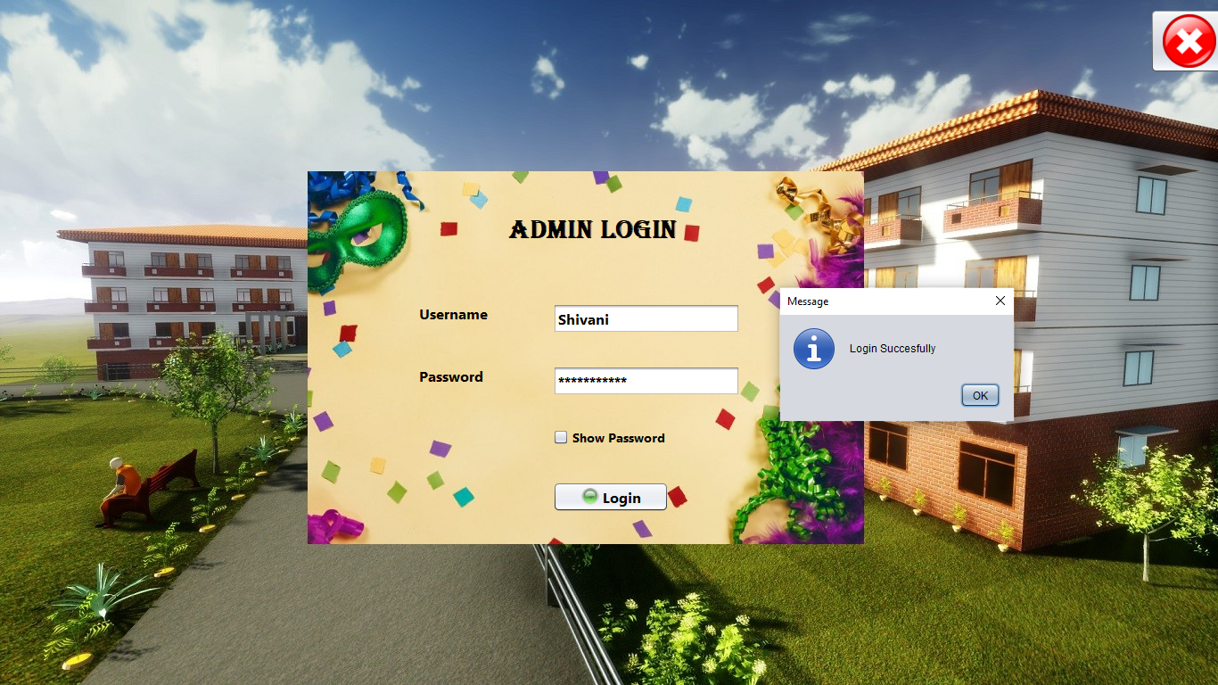

* Home Page

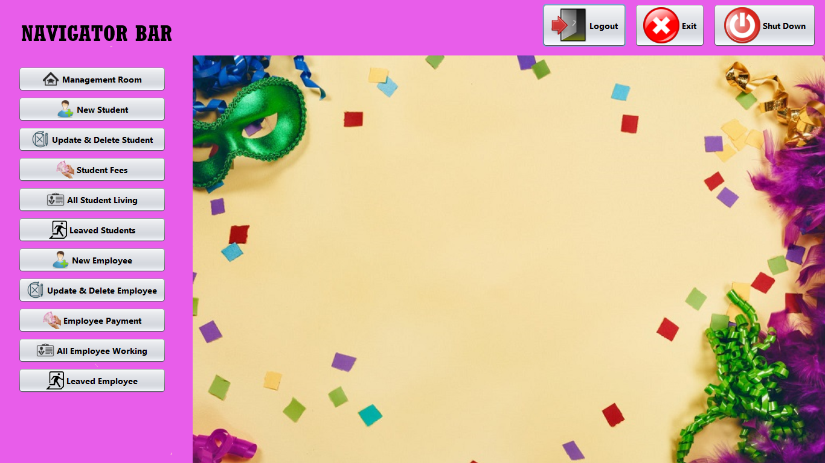

* Manage Room

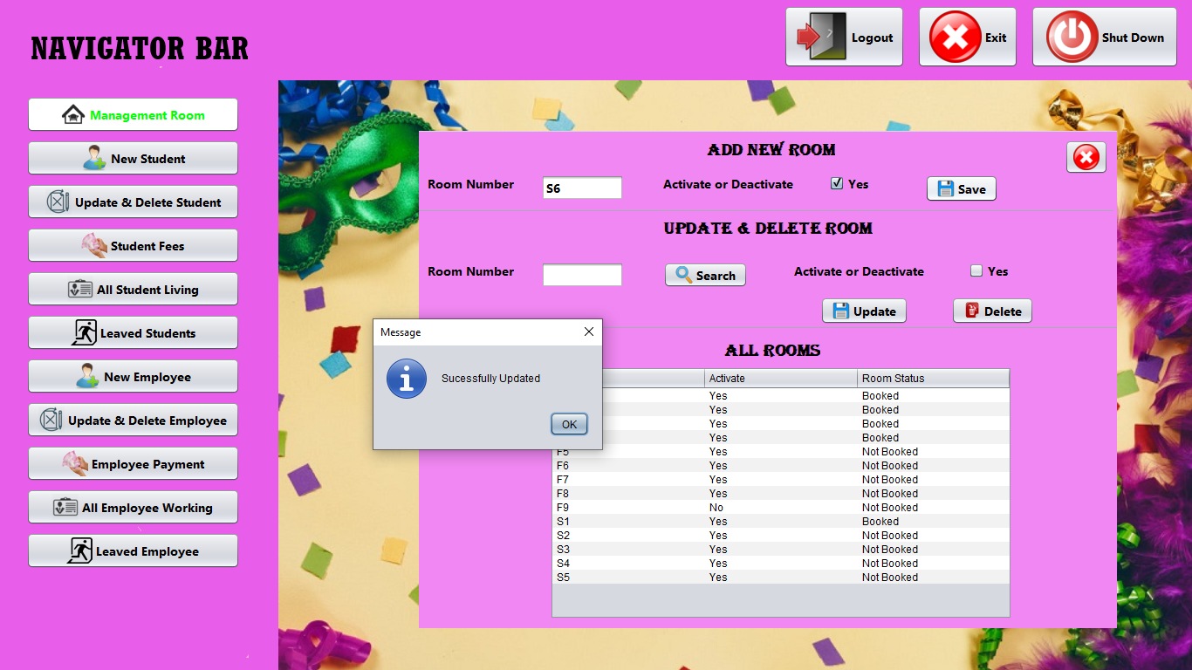

* Add New Student

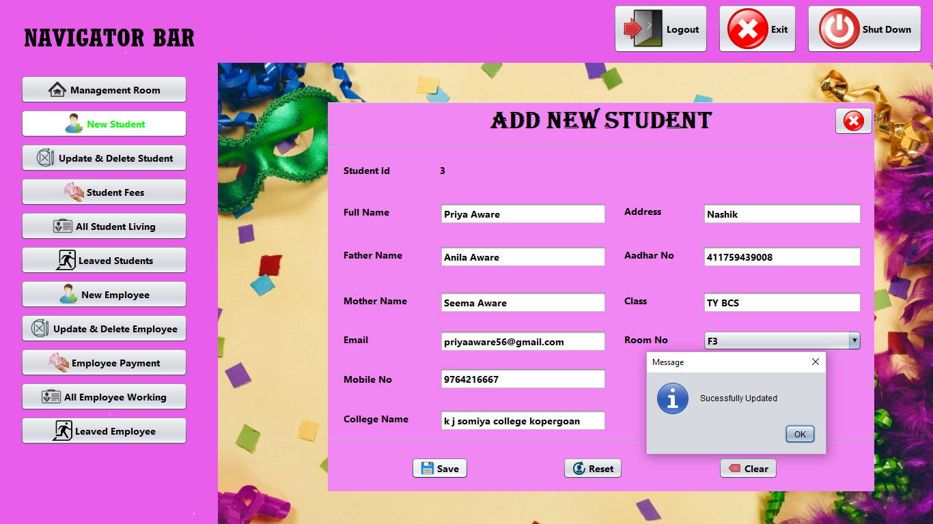

* Update Delete Student

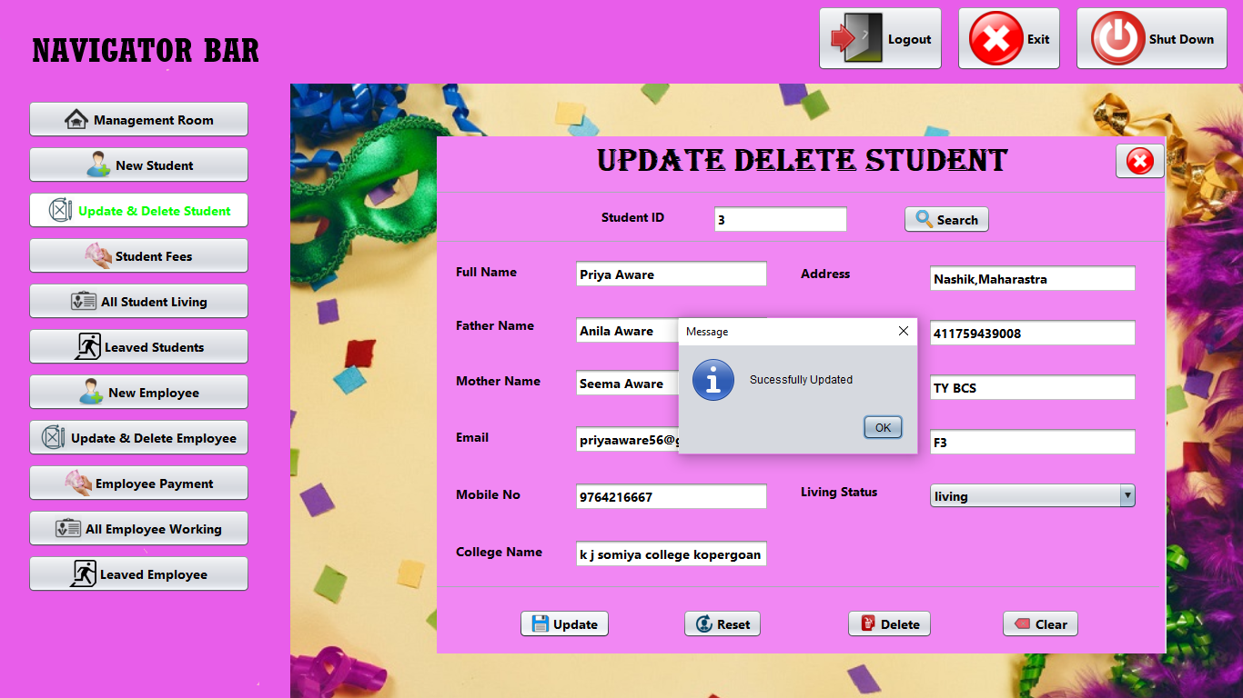

* Student Fees

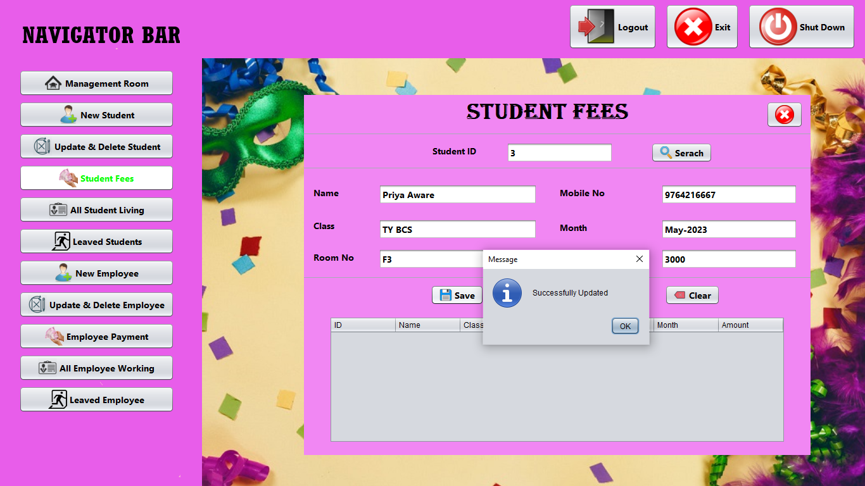

* Add New Employee

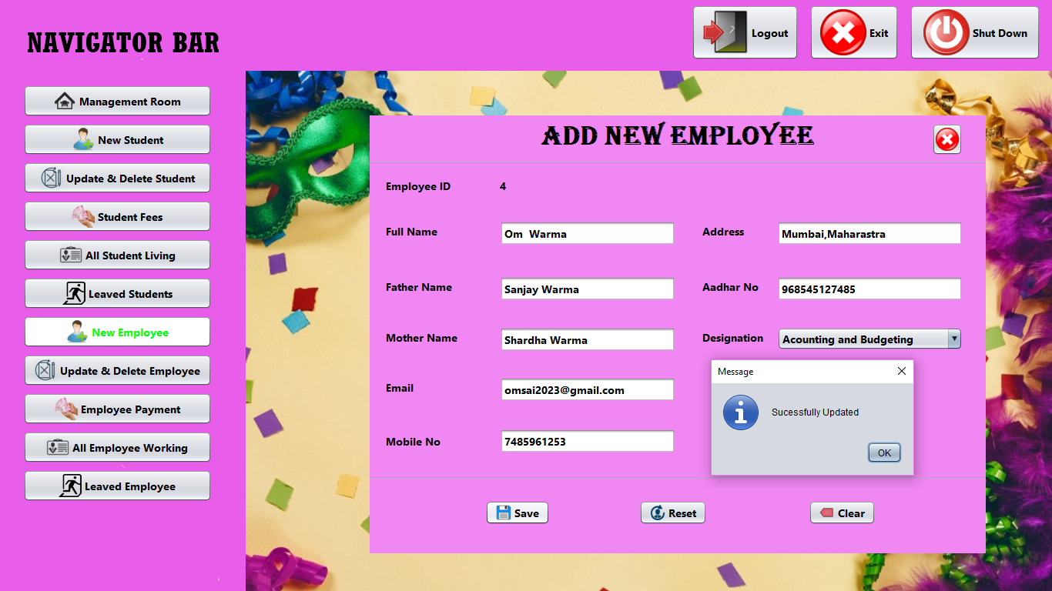

* Update Delete Employee

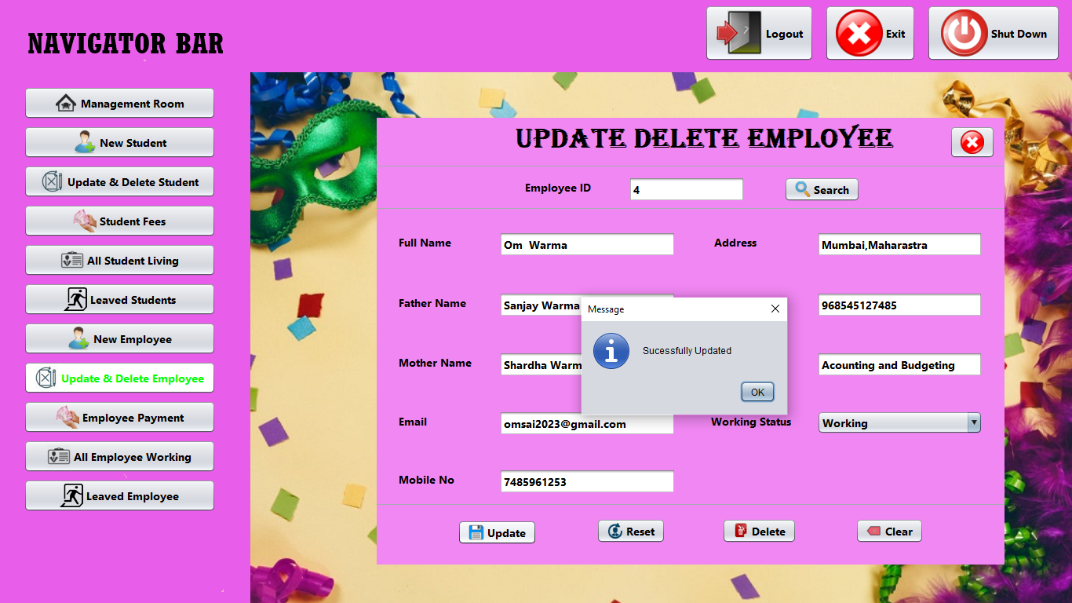

* Employee Payment

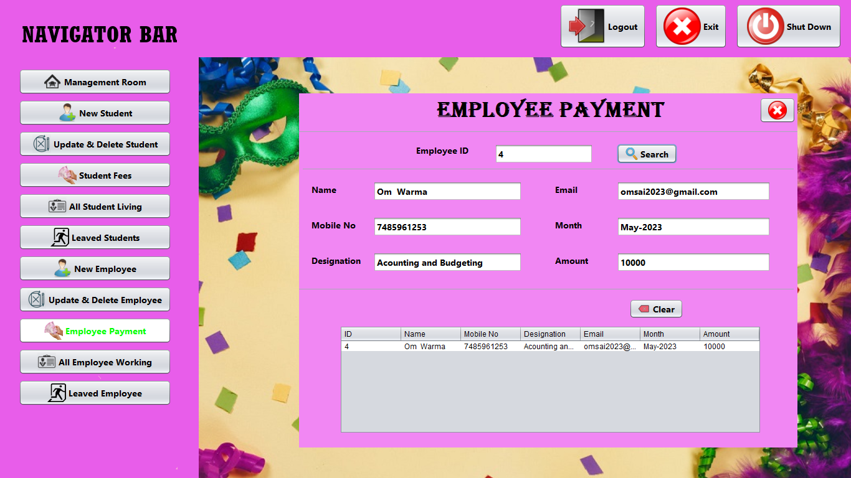

**Output Screens**

* Display All Rooms Information

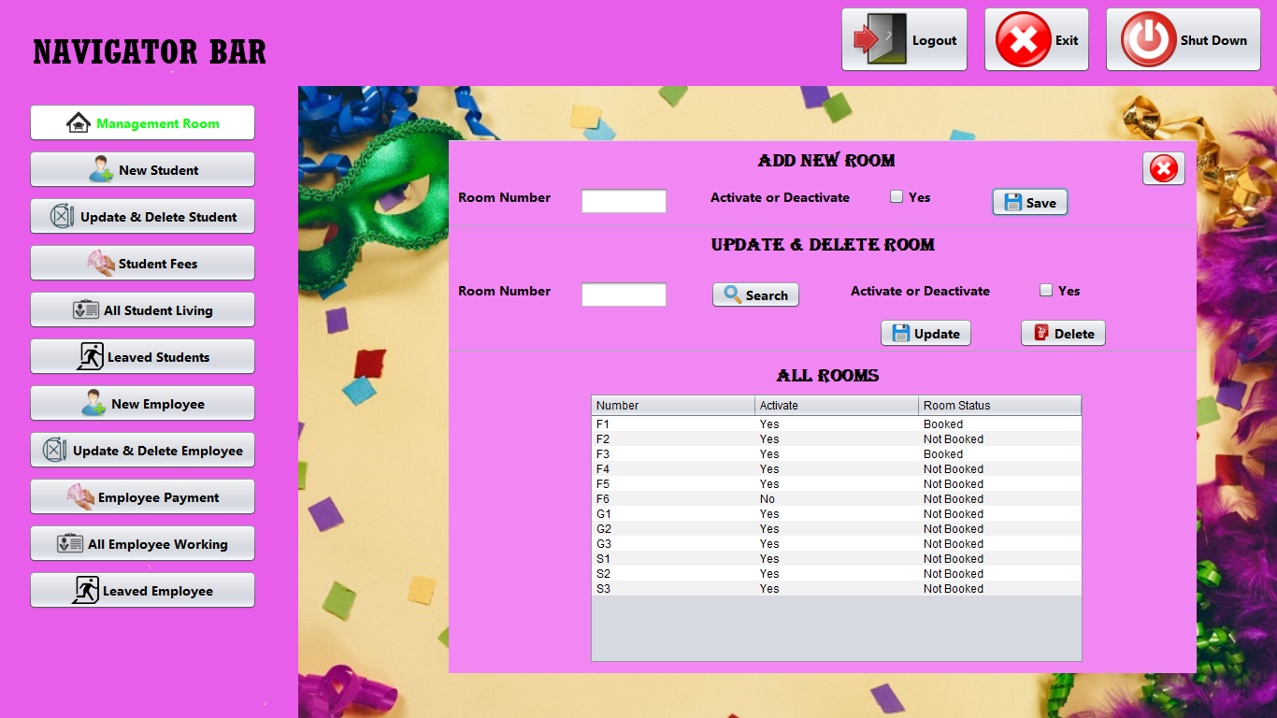

* Display All Student Details

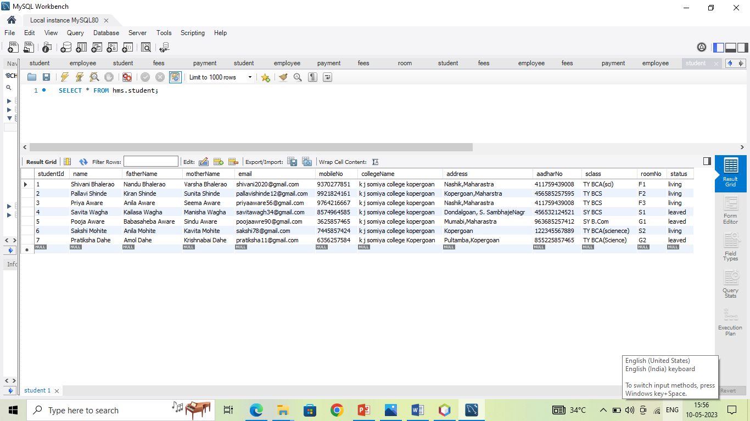

* Display Student Fees Details

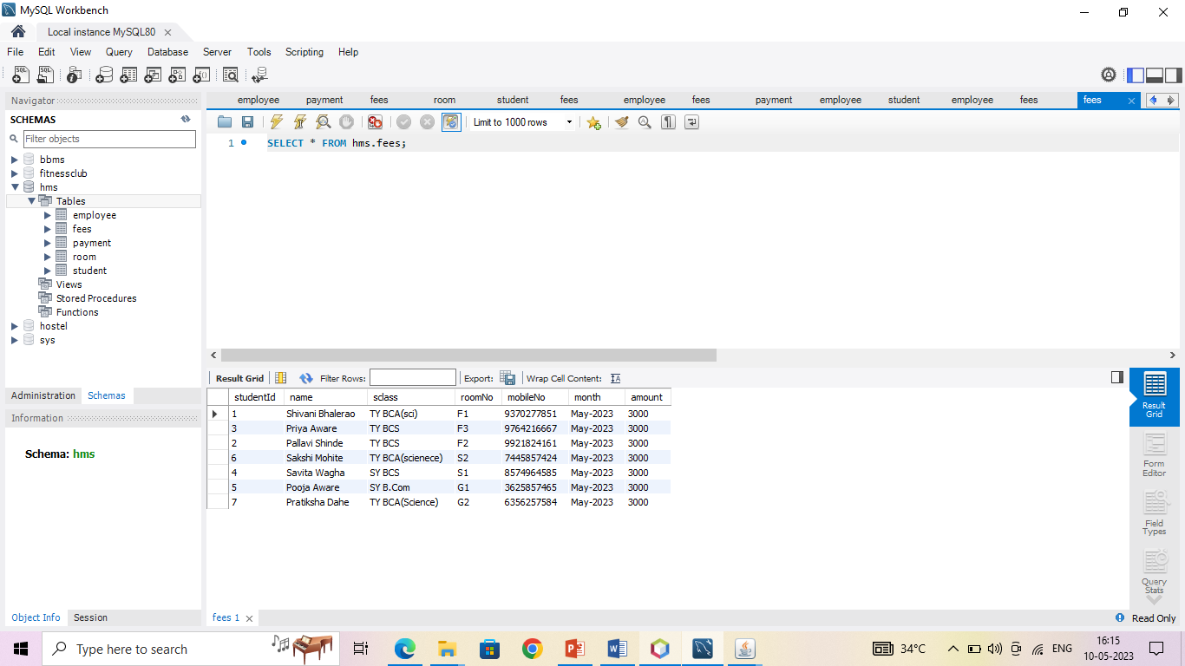

* Display All Employees Details

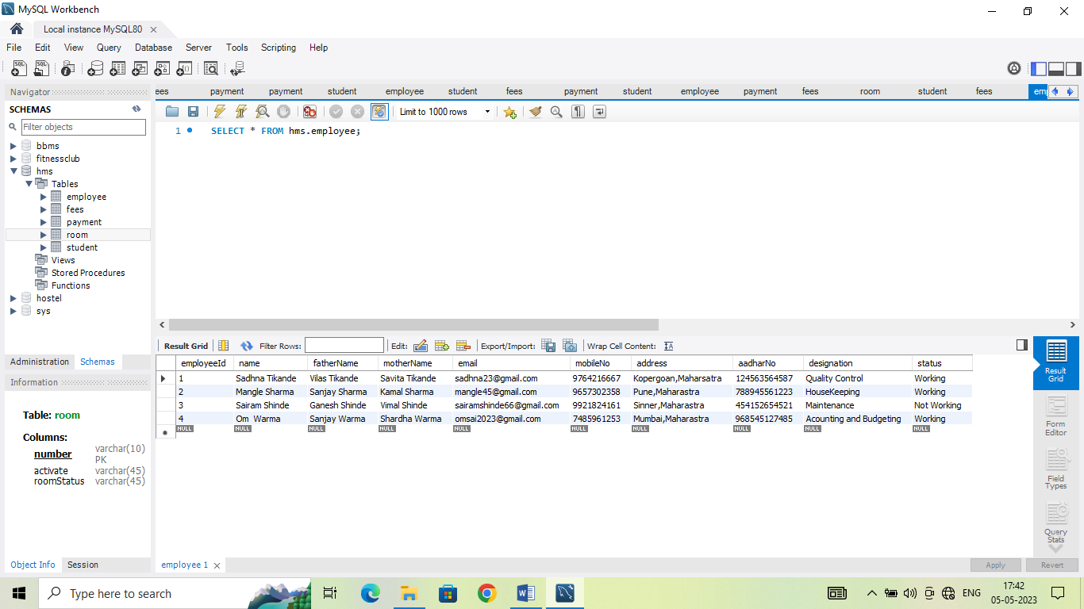

* Display Employee Payment Details

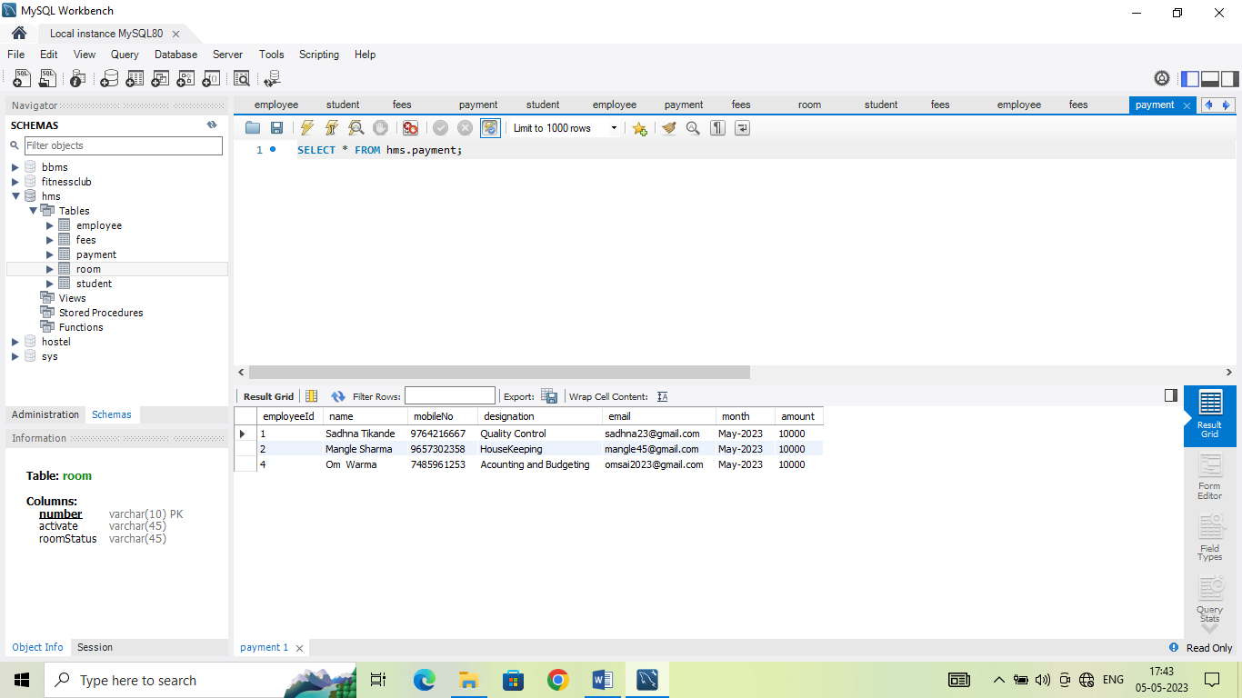

**Limitations**

* The main drawback of the proposed system is that, it is not web-based system.
* The proposed system is only handle by Admin
* This System store one time only one record

**Conclusion**

Hostel Management System is a customize and user-friendly software for hostel. It has been design to automate, manage and look after the overall processing of even very large hostel. It is capable of managing enquiry details, student details, payment details etc. Hostel Management System is customized and user-friendly software for hostel which provide hostel information, hostel account information. Hostel management software system is offering a maximum of stability, cost effectiveness and usability. It provides the most flexible and adaptable standards management system software solution for hostel.

**References**

* [www.Google.com](http://www.Google.com)
* [www.javaPoint.com](http://www.javaPoint.com)
* [www.youtube.com](http://www.youtube.com)
* [www.w3school.com](http://www.w3school.com)